**Database Management System**

**KCS 501**

1. List and discuss the primary rules of Armstrong Axioms.
2. A) Write short note on:

* Views
* Cursors and Procedures
* TRC and DRC

1. Write SQL query to get the names of employees who have Second Highest Salary
2. Discuss the different types of joins, intersection and minus taking appropriate example along with SQL queries.
3. A) Consider a relation scheme R = (M, N, O, P, Q, R) with the following functional dependencies:

{M → N, NO → P, Q → O, P → M}.What are the possible candidate keys, prime and non-prime attributes of relation R?

B) Write short note on:

* Lossless Decomposition with example.
* Dependency Preservation with example.

1. What is the highest normal form of relation R (A, B, C, D), given FDs **A--> B; CD--> B; A--> CD; CD--> A**?
2. Find the canonical cover of the following functional dependencies for the relational scheme R ( W , X , Y , Z ) –

X → W

WZ → XY

Y → WXZ

1. Consider a relation **R (A, B, C, D, E)** satisfying following functional dependencies:

**A→ B, B → E, C→ D** how many tables will be there in relation R after converting it into 3NF?

1. Discuss the 4NF and 5NF with example. Also elaborate how a relation R can be converted to 4NF and 5NF.
2. Given a relation R(X, Y, Z, W, P) and Functional Dependency set FD:

X → Y,

Y → P, and

Z → W

Determine whether the given R is in 3NF? If not convert it into 3 NF.

1. Consider a schema R(A, B, C, D) and following functional dependencies:

A→B,

B→C,

C→D,

D→B

Decomposed Relations are R1(A, B), R2(B,C) and R3(B,D).

Identify whether decomposed relations are lossless dependency and dependency preservation or not.

Relation

1. Elaborate the role of data redundancy and anomalies in the database normalisation.
2. the statement whether it is true or false and explain it with the help of an example:

i) A relation in which every key has only one attribute is in 2NF.

ii) A prime attribute can be transitively dependent on a key in a BCNF

1. Write a short note on:
2. 1NF
3. 2NF
4. 3NF
5. BCNF
6. Take an example of a relation and explain how tables are decomposed in case of 1NF, 2NF, 3NF, BCNF, 4NF and 5NF.
7. **Sample Tables**:

StudentDetails

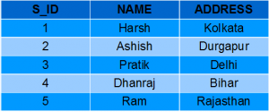

StudentMarks

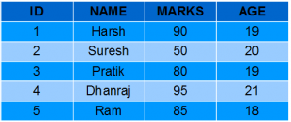

* Create a View named DetailsView from the table StudentDetails. Query.
* Create a view named StudentNames from the table StudentDetails. Query.